**Blowing Rock Historical Society**

**Membership Form**

**Blowing Rock Historical Society PO Box 804 Blowing Rock, NC 28605**

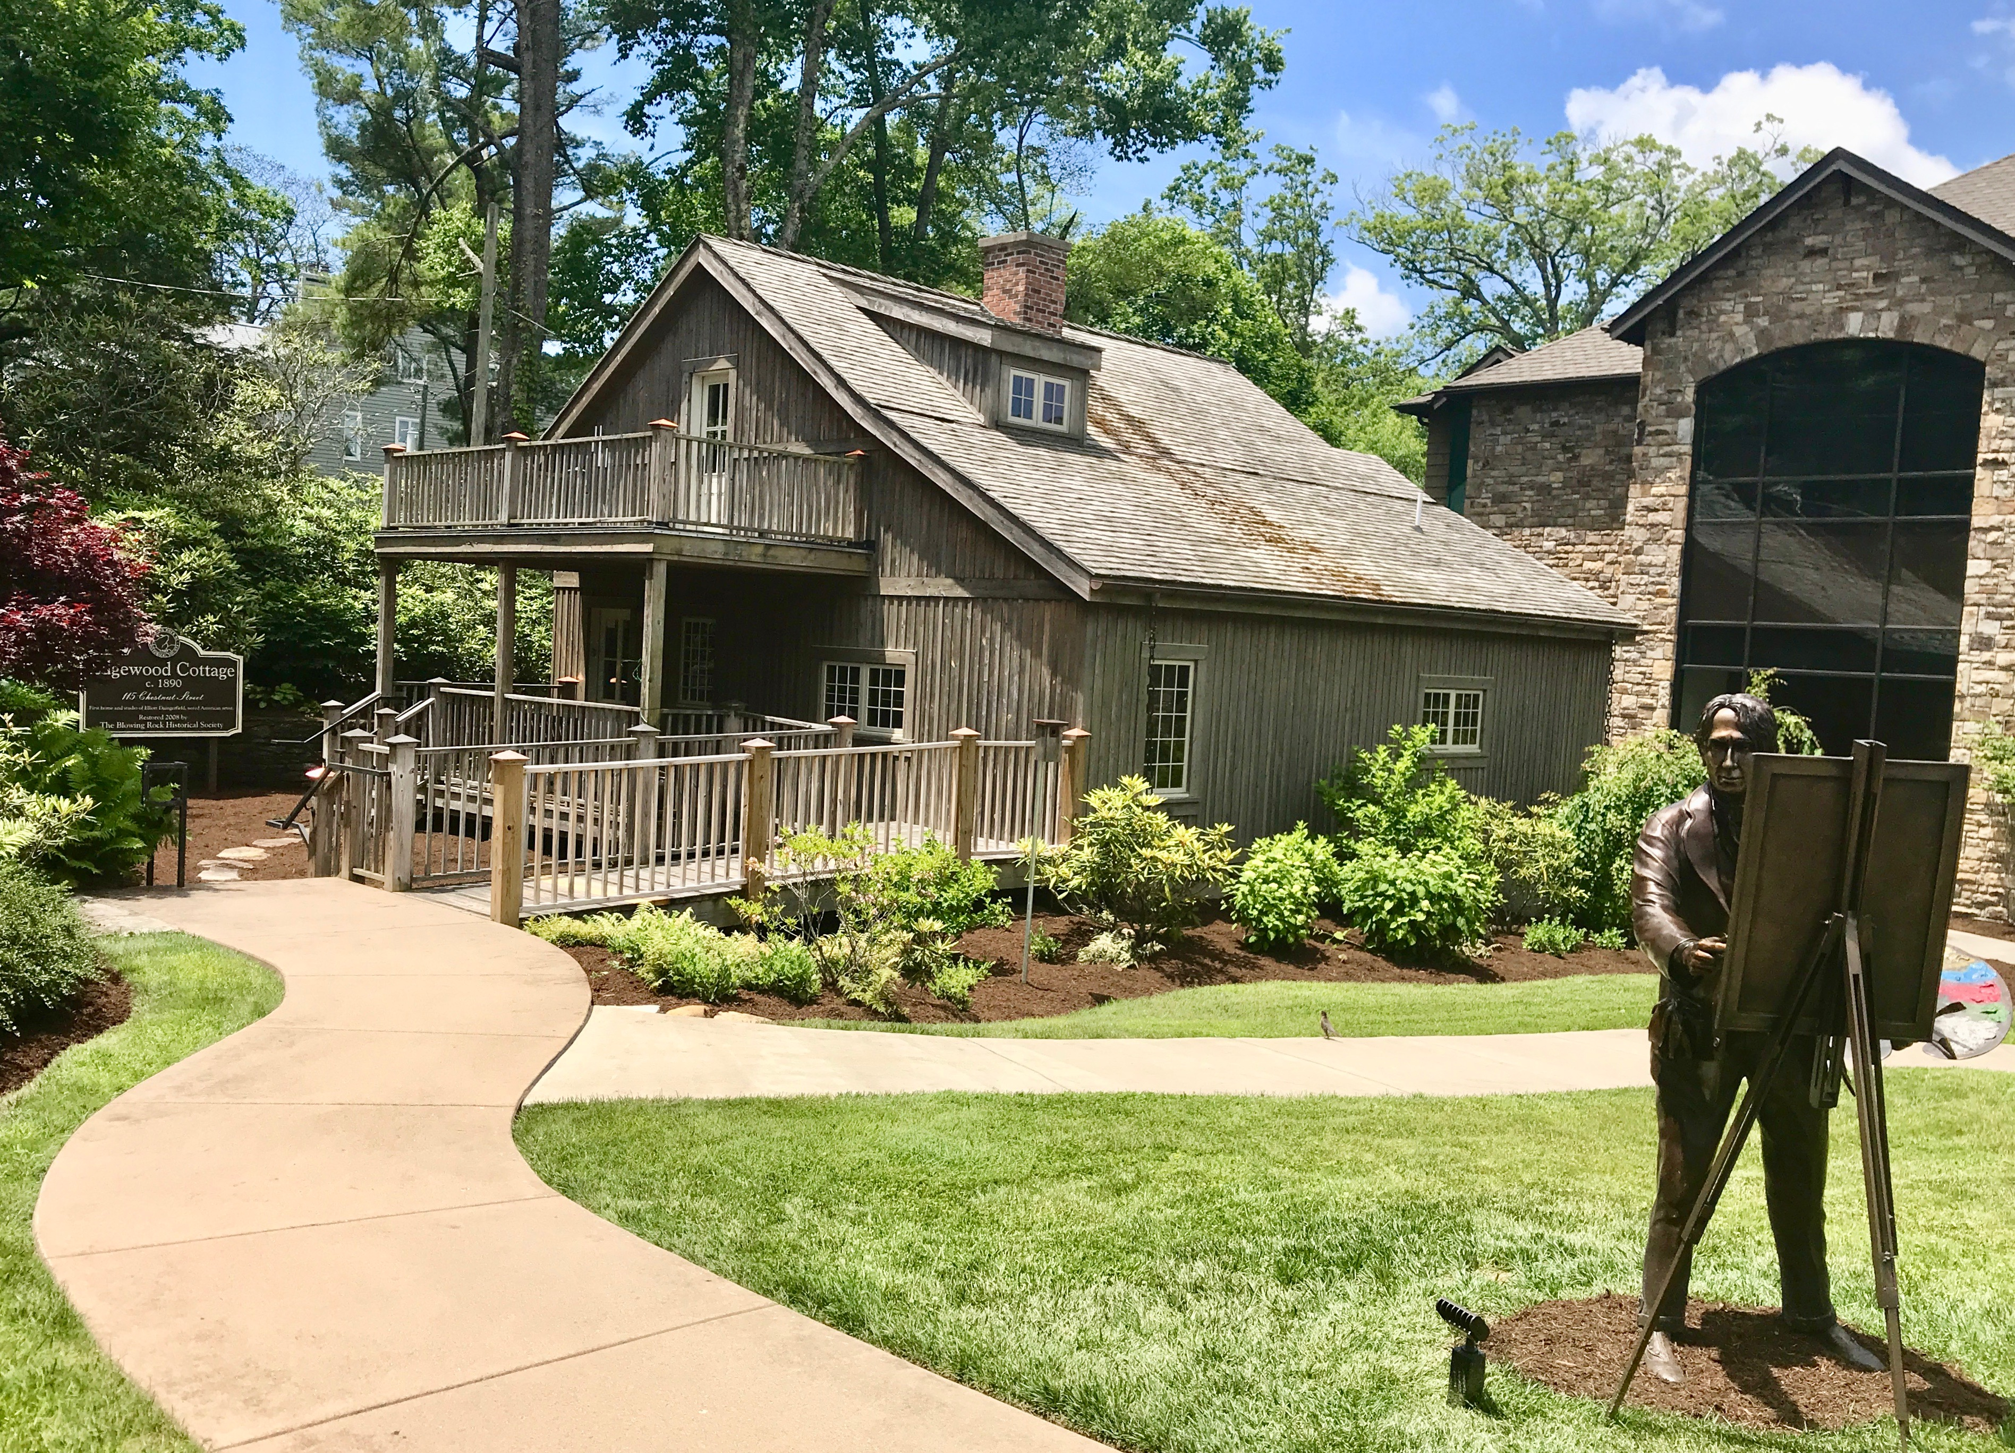**Contact Information**

Name(s):_____________________________________________________________________

Mailing Address:_______________________________________________________________

_____________________________________________________________________________

Email Address(es):______________________________________________________________

Home Phone:_________________________ Cell Phone:__________________________

**Communication Preference**

Please check any or all communications you wish to receive by email. If not checked, we will assume email communication for all.

___ Day-to-Day Communication ___ Newsl**etter**

**Membership Level**

___ Faculty/Student ($15) ___ Individual ($35)

___ Family ($50) ___ Patron ($100)

___ Founder ($500) ___ Business Supporter ($500)

___ Sustainer ($1,000)

Please mail check to the address referenced above.

**Volunteer Opportunities**

As a volunteer organization, we NEED your help – please check any area(s) that are of interest to you.

___ Artists in Residence ___ Curation & Exhibits

___ Events ___ Marketing/Publicity/Newsletter

___ Membership ___ Museum Docent

**Referrals**

Do you know of someone who might be interested in becoming a BRHS member? If yes, please list their name and contact information, and we will send them an invitation to join.

____________________________________________________________________________